**Jamal al-Din al-Afghani جمال الدين الافغاني (1838- 1897 )**

Mark D. Luce (AFFILIATION)

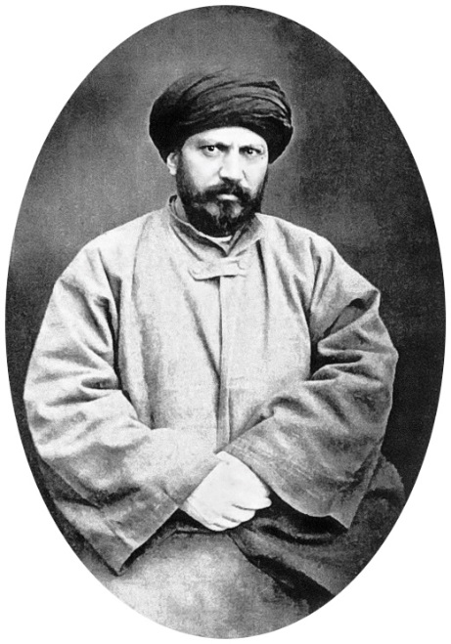

<http://en.wikipedia.org/wiki/Jamal_ad-Din_al-Afghani>

**Summary**

Jamal al-Din al-Afghani (1838-1897 ) is considered the ‘father of Islamic modernism.’ As a philosopher, writer, orator, and journalist, Al-Afghani affected Islamic thought from the Indian subcontinent, to Iran and the Middle East. He advocated for national liberation and was the founder of the revivalist movement, which later gave rise to the Muslim Brotherhood.

Of Iranian origin, al-Afghani travelled widely, spending time and working in Afghanistan, India, Iraq, Egypt, and Istanbul. His preaching and writings called for a Muslim revival, an abandonment of fatalism, and the application of intellect to work for freedom. He urged students to use journalism as a tool in the fight: to influence minds. He denounced Muslim rulers who opposed reform. He envisioned Muslims being governed in one state, free from western imperialism, and reviving the past glories of Islam. He pioneered an Islamic awakening for Muslims through his writings, teachings, speeches, and political organizations, which sparked anti-imperialist, reformist, and pan-Islamic political activities.

**Jamal al-Din al-Afghani (1838- 1897)**

Jamal al-Din al-Afghani is considered the ‘father of Islamic modernism.’ He took great pains to cloak his Iranian origins and identified himself as Afghan, thus the nisba, al-Afghani. No doubt this was to hide his Shi’ite upbringing, which would have presented obstacles for his mainly Sunni audiences and readers. Al-Afghani was more a philosopher than a cleric. He saw Islam through a political light instead of a religious one.

Four of al-Afghani’s Arab admirers – Muhammad Abduh , Jurji Zaidan Adib Ishaq and Rashid Rida – provide biographical details about al-Afghani that ideally fit what he would have wanted others to believe about him. Keddie’s ground-breaking biography confirms his Iranian origins and refers to Abduh’s and Zaidan’s accounts as the standard biography.

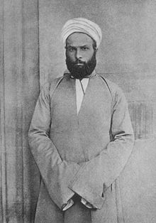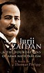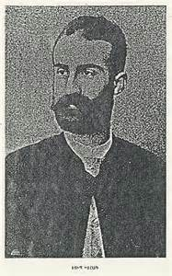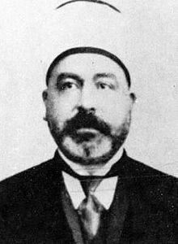

**Abduh Zaidan Ishaq Rida**

Al-Afghani’s studies and travels led him to India, Afghanistan, Persia, Istanbul, Egypt and Europe. While residing in India he wrote and published his *The Refutation of the Materialists* (1881), a rejection of the ideas of Sayyid Ahmad Khan. This work was later translated by his student Muhammad Abduh and published in Beirut in 1886 as *al-Radd ‘ala al-dahriyyin.* In Paris, with the assistance of Muhammad Abduh, al-Afghani published *al-‘Urwat al-wuthqa’* (*The Firmest Robe*). This journal earned him a place in French intellectual circles. He was invited to Persia by Shah Nasir al-din to act as his special advisor but al-Afghani’s differences led to his departure. Again, in 1889, al-Afghani was offered the position of grand vizier by the Shah but in 1891, al-Afghani’s criticism of the ruler led to his deportation.

**Influence on Egypt**

Al-Afghani’s teaching had the greatest impact on the Egyptians. He profoundly influenced Egyptian youth in Cairo and Alexandria. He advocated for constitutional liberties and liberation from colonialist powers. In Cairo, al-Afghani’s students Muhammad Abduh and Sa’ad Zaghlul emerged as heroes of Egyptian independence. Abduh became the chief mufti of Egypt, while Zaghlul, an Egyptian revolutionary, became a leading statesman and Egyptian Prime Minister.

Al-Afghani spent the last years of his life attached to the Ottoman court of Sultan ‘Abd al-Hamid II. His efforts, speeches, and writings urged Muslims to rebel against the imperial powers, to unite and to reform. Only toward the end of his life was he a true advocate of pan-Islamism. He was a major Muslim reformist, who established a bridge to modernity, between tradition Islamic culture and the new scientific knowledge of the West.

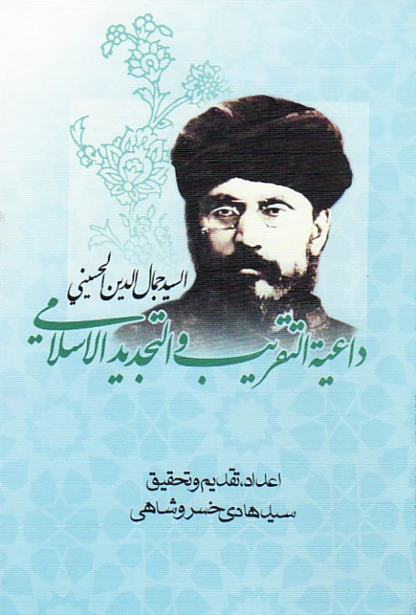 **Jamāl al-Dīn al-Ḥusaynī, dā‘iyat al-taqrīb wa-al-tajdīd al-Islāmī  
by** [**Khusrūshāhī, Sayyid Hādī**](http://www.arabicbookshop.net/main/CatalogueFilter.asp?auth=Khusrushahi,%20Sayyid%20Hadi&sort=6&type=AUTHOR)  **Issue Year: 2010**

**Further Reading:**

**Websites:**

<http://themiddleeastandislam.blogspot.com/2012/05/jamal-al-din-al-afghani.html> (Zackery M. Heern, professor of Middle East studies at Murray State University, Accessed 6/26/2015)

‘Jamal al-Din al-Afghani’ *Encyclopedia Iranica* (<http://www.iranicaonline.org/articles/afgani-jamal-al-din>. Accessed 6/26/2015).

‘Biography of Jamal al-Din al-Afghani’ (<http://www.cis-ca.org/voices/a/afghni.htm>. Accessed 6/26/2015).

**Books and Articles:**

 Afshar, Iraj and Mahdawi, Asghar. *Majmu’a-yi asnad wa madariki chap nashuda dar bara-yi Sayyid Jamal al-Din mashhur be-Afghani* (Tehran: Tehran University Press, 1963) (in Persian)

Hourani, Albert. *Arabic Thought in the Liberal Age: 1789-1939* (Cambridge: Cambridge University Press, 1982)

 Keddie, Nikki. *An Islamic Response to Imperialism: Political and Religious Writings of Sayyid Jamal al-Din ‘al-Afghani’* (Berkeley: University of California Press, 1983)

____________. ‘Sayyid Jamal al-Din al-Afghani’s First Twenty-Seven Years: The Darkest Period’ *Middle East Journal*, Vol. 20, No. 4 (Autumn, 1966), 517-533.

 ___________. *Sayyid Jamal al-Din Afghani: A Political Biography* (Berkeley: University of California Press, 1972)

Kenny, L.M.. ‘Al-Afghani on Types of Despotic Government’ *Journal of the American Oriental Society*, Vol. 86, No. 1 (Jan-Mar, 1966), 19-27.

Sayid Jamal al-Din al Afghani, Abdul-Hadi Ha’iri. ‘Afghani on the Decline of Islam’ *Die Welt des Islams,* Vol. 13, Issue ½ (1971), 121-125.

List of works (from Albert Kudsi-Zadeh)

http://www.jstor.org/stable/4282142

Jamal al-Din al-Afghani: A Select List of Articles

Author(s): A. Albert Kudsi-Zadeh

Source: Middle Eastern Studies, Vol. 2, No. 1 (Oct., 1965), pp. 66-72

<http://www.h-net.org/~bahai/areprint/afghani/namihha/namihha.htm>

A. Articles by Afghani:

1. 'Ahwal Faris al-hadira', Diya' al-Khafiqayn, London, Year I, No. 1, 1892, p. 8. A letter signed al-Sayyid calling upon Persians to overthrow the government of Nasir-ud-Din Shah.

2. 'Bilad Faris', Diya' al-Khafiqayn, London, Year I, No. 2, 1892, pp. 14-16. A letter signed 'al-Sayyid al-Husayni' in which Afghani deplores conditions in Persia.

3. 'al-Fiqh al-islami', Diya' al-KhafiqaynL, ondon, Year I, No. 3, 1892, p. 30. Review of a book in French by Sawas Pasha.

4. 'al-Hujja al-baligha', Diya' al-KhafiqaynL, ondon, Year I, Nos. 4-5, 1892, pp. 50-52. Another letter secretly distributed in Persia and signed 'K.H.F.-Q.S.T.'

5. 'al-Hukuma al-istibdadiyya', al-Manar, Cairo, Vol. III, pp. 577-582 and pp. 601-607. Reproduced from Misr, Alexandria, No. 33, 22 Safar, 1296.

6. 'al-'Illa al-haqiqiyya li-sa'adat al-insan,' al-Manar, Cairo, Vol. XXIII, pp. 37-45. Foreword to al-Bayan fi al-Ingliz wa al-Afghan, a collection of articles reportedly by al-Afghani, which appeared in Misr and later published in book form in Alexandria, 1878.

7. 'Inna fi dhalika la-dhikra li-man kana lahu qalb aw alqa al-sam' wa-huwa shahid', al-Manar, Cairo, Vol. II, pp. 4-12. A discussion of the bases of Islam and

Christianity, reprinted from al-'Urwa al-Wuthqa.

8. 'wa-I'tasimu bi-habl Allah jami'an wala tafarraqu,' al-Manar, Cairo, Vol. XXIV, pp. 28-32. An article which originally appeared in al-'Urwa al-Wuthqa, No. 5, urging Muslims to unite.

9. 'Kitab Da'irat al-Maeari 'al-Jinan, Beirut, 1879,Vol. X, pp. 306-308. An appreciation of Butrus al-Bustani's book.

10. 'Kitab Tidhkar al-'alam al-islami,' Diya' al-Khafiqayn, London, Year I, Nos. 4-5, 1892, p. 72. An appreciation of the book Souvenirs du monde musulman by Charles Mismer, published in Paris, 1892.

11. 'Kitaban siyasiyyan,' al-Manar, Cairo, Vol. X, pp. 820-833. Two letters on Persia; the first addressed to the Chief Mujtahid in Samarra and the second, entitled 'Bilad Faris,' addressed to all the 'ulama in Persia.

12. 'al-Maqalat al-jamaliyya: 1. al-sharq wa al-sharqiyyun,' al-Manar, Cairo, Vol. XXV, pp. 535-539. Reproduced from Abu Nazzara Zarqa, Paris, 1883.

13. 'al-Maqalat al-jamaliyya: 2. fi al-shawahid al-tarikhiyya Cala ida'at al-mamalik al-sharqiyya,' al-Manar, Cairo, Vol. XXV, pp. 593-598.

14. 'al-Maqalat al-jamaliyya: 3. al-siyasa al-ingliziyya fi al-mamalik al-sharqiyya wa asbab al-harb bi-Misr,' al-Manar, Cairo, Vol. XXV, pp. 756-760. Reproduced from al-Nahla, London, Year 5, No. 3.

15. 'al-Maqalat al-jamaliyya: 4. kitab lahu fi al-difa' 'an al-dawla al-'uthmaniyya,' al-Manar, Cairo, Vol. XXVI, pp. 44-47. A letter from Afghani to al-Basir, Paris, February 1883.

16. 'Ra'y hakim sharqi,' al-Muqtataf, Cairo, No. 5, Shawwal 1343. A letter to Haj Daghistani dated 15 December, 1881. (Cited by Khan Malek Sasani, Siyasatgaran-e Dowre-ye Qajar, Tehran, 1960).

17. 'al-Umma wa sultat al-hakim al-mustabidd,' al-Manar, Cairo, Vol. IX, pp. 905-906. Reproduced from al-'Urwa al- Wuthqa, No. 14.

18. 'Zalamat al-umma... wa-dara'at al-milla,' Diya' al-Khafiqayn, London, Year I, No. 3, 1892, pp. 31-33. A letter secretly distributed in Persia and signed 'al-Sayyid al-Husayni.'

19. Articles in Misr, Alexandria, 1878, including those signed 'Muzhir Ibn Waddah,' a pseudonym used by Afghani. (Cited by Adib Ishaq, MuntakhabatA, lexandria, n.d., p. 118).

# Al-Afghani’s Major Works

1. *Al-Ta’liqat ‘ala sharh al-Dawwani li’l-‘aqa’id al-‘adudiyyah* (Cairo, 1968). Afghani’s glosses over Dawwani’s commentary on the famous *kalam* book of ’Adud al-Din al-‘Iji called *al-‘aqa’id al-‘adudiyyah*.
2. *Risalat al-waridat fi sirr al-tajalliyat* (Cairo, 1968). A work dictated by Afghani to his student M. ‘Abduh when he was in Egypt.
3. *Tatimmat al-bayan* (Cairo, 1879). A political, social and cultural history of Afghanistan.
4. *Hakikat-i Madhhab-i Naychari wa Bayan-i Hal-i Naychariyan*. First published in Haydarabad-Deccan, 1298/1881, this is Afghani’s most important intellectual work that he published during his lifetime. It is a scathing criticism and total rejection of naturalism which Afghani also calls ‘materialism’. The book has been translated into Arabic by M. ‘Abduh as *al-Radd ‘ala al-dahriyyin* (The Refutation of the Materialists).
5. *Khatirat Jamal al-Din al-Afghani al-Husayni* (Beirut, 1931). A book compiled by the Lebanese journalist Muhammad Pasha al-Mahzumi. Mahzumi was present in most of Afghani’s talks in the last part of his life and developed his conversations in to the present book. The book contains important information about Afghani’s life and ideas.